Business Owners – protect water quality inside, outside & under your building!
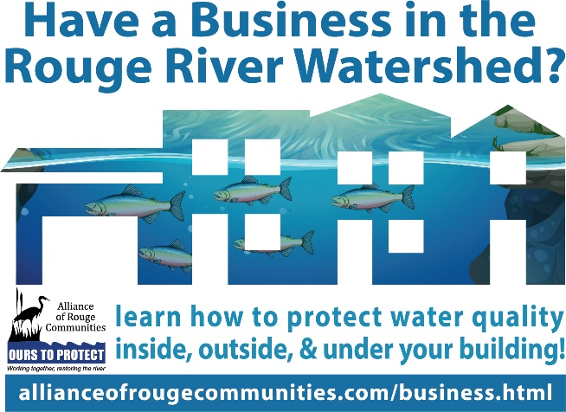
Businesses have a direct effect on the water quality in the Rouge River watershed. When rain and snow/ice melt travel across the land (watershed) and into storm drains, it is called stormwater or runoff. Runoff picks up trash, animal waste, chemicals, sediments and dissolved substances until it discharges into the nearest waterbody. Even if your business is not next to the river, your actions still have an impact on the Rouge River watershed. These bodies of water impacted by runoff provide recreational opportunities, habitat for wildlife, and may even provide drinking water for communities.
The way you use, dispose and store chemicals, batteries, wastes and other materials inside your building can influence water quality in the Rouge River. Make sure your business stores chemicals in a designated area which includes secondary containment in case the original containers leak. Also consider implementing a recycling station for plastic, paper/cardboard, glass, aluminum and batteries to protect the environment.
How you maintain and clean your parking lots, dumpsters and storage areas outside your building play an important role in the health of the Rouge River. Always keep dumpster areas clean and lids closed so items don’t blow away. Inspect containers and waste disposal areas regularly for leaks and replace or repair them immediately if found. To protect water quality it is important to clean up leaks or spills outside immediately with dry absorbent and dispose of properly; never wash it down the storm drain.
The lawn surrounding your business and how you maintain it also plays an important role in water quality. Limit the use of herbicides, pesticides or fertilizers and never apply them close to any watercourse. Always follow a product’s label for proper use and application. Businesses should also consider planting rain gardens around buildings. Their deep roots slow runoff and provide filtration before stormwater enters the river.
Even things under your building that you can’t see, like pipes that were changed with renovations or expansion, can affect the water quality in the Rouge River. Never reroute sanitary drains on your property without verifying their connection to a sanitary sewer system. If a sewer pipe is mis-connected to a storm drain system, this is an illicit connection and is harmful to water quality. If you are contacted about E. coli levels close to your business by city or county authorities, work with them to test your sanitary connections and if something is found, correct it.
Adopting Best Management Practices (BMPs) and training your employees to use them inside, outside and under your building will have a positive impact on your profits, customers, employees, wildlife and their habitat, and even the communities downstream! To learn more BMPs you can adopt in your business to protect water quality in the Rouge River visit www.allianceofrougecommunities.com/business.html.

